**Traffic Management Plan Application**

Due to the complexities of Traffic Management Plans, this questionnaire will help streamline the information for Double-O Permits & Project Services Inc in the development process for the move. Since each Province or State requires different information for each large move, or have different requirements based on the overall dimensions or weight involved, we will work together to finalize the required product for your need.

**Section A: Company Information**

|  |  |  |  |  |  |  |  |  |  |  |  |  |
| --- | --- | --- | --- | --- | --- | --- | --- | --- | --- | --- | --- | --- |
| Transport Company Name: | | | | |  | | | | | | | |
| Street Address: | | | |  | | | | | | | | |
| City: |  | | | | | Prov./State: |  | | | | Postal Code/Zip: |  |
| Telephone: | |  | | | | | | Fax: |  | | | |
| Contact Name: | | |  | | | | | Email: | |  | | |

**Section B: Load Information**

|  |  |  |  |  |  |  |  |  |  |  |  |  |
| --- | --- | --- | --- | --- | --- | --- | --- | --- | --- | --- | --- | --- |
| Load: |  | | | | | | | | | | | |
| Make: | |  | | | | Model: |  | | Serial #: | |  | |
| Length: | | |  | Width: |  | | Height: |  | | Weight: | |  |

**Section C: Loaded Overall Dimensions**

|  |  |  |  |  |  |  |  |
| --- | --- | --- | --- | --- | --- | --- | --- |
| Length: |  | Width: |  | Height: |  | Weight: |  |

**Section D: Shipper and Project Information**

|  |  |  |  |
| --- | --- | --- | --- |
| Shipper Name: | | |  |
| Address: |  | | |
| Project Name: | |  | |
| Location: |  | | |

**Section E: Equipment Information**

This section describes the type of equipment used for the movement. Please be as specific as possible (i.e. counterweights, towed or fifth-wheel hookup, dollies, type of steering, etc.).

*Fill in only those vehicles that apply to your configuration.*

|  |  |
| --- | --- |
| Tractor: |  |

|  |  |
| --- | --- |
| Jeep: |  |

|  |  |
| --- | --- |
| Trailer: |  |

|  |  |
| --- | --- |
| Booster: |  |

|  |  |
| --- | --- |
| Dolly: |  |

|  |  |
| --- | --- |
| Hydraulic Trailer: |  |

|  |  |
| --- | --- |
| Dual Lane: |  |

For trunnion or dual lane equipment, please fill in Appendix A, or attached schematic with corresponding information. Please complete Appendix B for axle configuration or attached complete schematic.

|  |  |  |  |  |
| --- | --- | --- | --- | --- |
| How many axles per equipment? Also identify if any of them are steerable  *(Fields under tractor have been left blank for you to enter, depending on configuration)* | Tractor: | 4 | Steerable | Yes, steer |
|  |  | Steerable |  |
|  |  | Steerable |  |
|  |  | Steerable |  |
|  |  | Steerable |  |
|  |  | Steerable |  |

**Section F: Routing**

|  |  |
| --- | --- |
| Origin: |  |
| Destination: |  |
| Route: |  |



Was a route survey performed? If yes, please attach copy of survey.



If No, do you require one?



Has an engineering analysis been performed? If yes, please attached complete report.



In No, do you require one?

Are there additional jurisdictions required for the same load? (i.e. bordering Province/State, County, Municipality, City, Township, etc.)

|  |
| --- |
|  |

1. Do you allow Double-O Permits & Project Services Inc to contact utility companies on your behalf for quotes if the load potentially requires them?



1. Do you allow Double-O Permits & Project Services Inc to contact bucket truck companies for traffic signals on your behalf for quotes if the load potentially requires them?



1. Do you allow Double-O Permits & Project Services Inc to contact Police authorities (if required) on your behalf for quotes, requirements and availability?



**Section G: Contacts**

|  |  |  |  |
| --- | --- | --- | --- |
| Driver Name: |  | Cell Phone: |  |
| Project Supervisor: |  | Cell Phone: |  |
| Site Supervisor: |  | Cell Phone: |  |
| Supervisor of Operations: |  | Cell Phone: |  |
| Escort Supervisor: |  | Cell Phone: |  |

**Section H: Timing**

|  |  |
| --- | --- |
| What approximate date is the move planned for? |  |
| How many loads are expected? |  |
| If multiple loads, how many daily (for projects) |  |
| What the expected completion date of the project? |  |

**Disclaimer**

The precision of the Traffic Management Plan and any turn radius drawings depends on the accuracy of the information provided by the client. Double-O Permits & Project Services Inc cannot be held responsible for any erroneous information provided or any changes made during movement. The study is generally made from the most recent images provided by Google Maps/Google Earth or by any GIS mapping available in the region.

I hereby acknowledge that I have read and responded accurately and truthfully all required information so that Double-O Permits & Project Services Inc can develop a Traffic Management Plan for the movement of said Super Load.

|  |  |  |
| --- | --- | --- |
|  |  |  |
| Name |  | Title |
|  |  |  |
| Signature |  | Date |
| Comments (any additional comments or information pertaining to the load) ↓↓↓↓ | | |
|  | | |

**Appendix A: Trunnion or Dual Lane Measurements**

*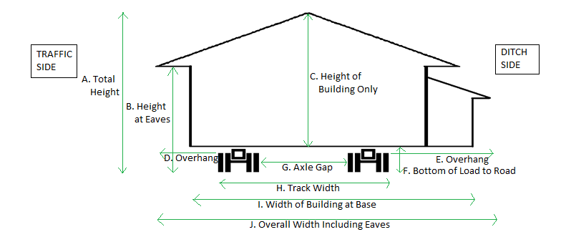** Fill in only those measurements that apply to your load.*

|  |  |  |  |  |  |  |  |  |  |  |  |  |
| --- | --- | --- | --- | --- | --- | --- | --- | --- | --- | --- | --- | --- |
| A. |  | | | | |  | | B. |  | | | |
| C. |  | | | | |  | | D. |  | | | |
| E. |  | | | | |  | | F. |  | | | |
| G |  | | | | |  | | H. |  | | | |
| I. |  | | | | |  | | J. |  | | | |
| Overall Length: | |  | | Beam Length: |  | | | | | Length of Building at Base: | |  |
| Effective Rear Overhang: | | |  | | | | Trailer Length: | | | |  | |



Do Dollies have built-in lifting capabilities?



Do Dollies have built-in steering capabilities?

**Appendix B: Axle Configuration**

|  |  |  |  |  |  |  |  |
| --- | --- | --- | --- | --- | --- | --- | --- |
| **Axle #** | **Equipment Type** | **Number of Tires** | **Mfg. Rated Axle Capacity** | **Tire Width** | **Tire Rating** | **Requested Weight per Axle** | **Inter-axle Spacing** |
| 1 | Steer | 2 | 14,600 lbs | 12 | 14,780 lbs | 14,000 |  |
| 18’-1” |
| 2 |  |  |  |  |  |  |
|  |
| 3 |  |  |  |  |  |  |
|  |
| 4 |  |  |  |  |  |  |
|  |
| 5 |  |  |  |  |  |  |
|  |
| 6 |  |  |  |  |  |  |
|  |
| 7 |  |  |  |  |  |  |
|  |
| 8 |  |  |  |  |  |  |
|  |
| 9 |  |  |  |  |  |  |
|  |
| 10 |  |  |  |  |  |  |
|  |
| 11 |  |  |  |  |  |  |
|  |
| 12 |  |  |  |  |  |  |
|  |
| 13 |  |  |  |  |  |  |
|  |
| 14 |  |  |  |  |  |  |
|  |
| 15 |  |  |  |  |  |  |
|  |
| 16 |  |  |  |  |  |  |
|  |
| 17 |  |  |  |  |  |  |
|  |
| 18 |  |  |  |  |  |  |
|  |
| 19 |  |  |  |  |  |  |
|  |
| 20 |  |  |  |  |  |  |
|  |
| **Total Weight Requested:** | | | | | |  |  |